MobileNetV2-Based Self-Supervised Model for Skin Cancer Detection with NT-Xent Loss and DullRazor Artifact Removal

D.Kanmani ^{(1,2)}  ^{1.} Research Scholar,  Department of Computer Science and Engineering  Amrita School of Engineering,  Amrita Vishwa Vidyapeetham, Chennai  ^{2.} Assistant Professor  Department of Information Technology,  Jeppiaar Institute of Technology  Chennai-631 604  dkanmani1997@gmail.com | Annamalai R  Department of Computer Science and Engineering, Amrita School of Computing,  Amrita Vishwa Vidyapeetham,  Chennai, India

Abstract

The skin, the body's largest organ, plays a vital role in protection and regulation, making its health essential. Skin cancer (SC), one of the most common cancers, is increasing worldwide and poses significant risks if diagnosed too late. Accurate detection is challenging due to the subtle and overlapping characteristics of SC, which often lead to diagnostic errors. Deep learning (DL) has emerged as an effective approach for analyzing complex dermatological data and improving diagnostic accuracy through precise pattern recognition. However, most DL-based solutions heavily depend on large labeled datasets, which are often limited in the medical domain. In this study, we suggest a lightweight and efficient self-supervised learning framework for SC detection based on the MobileNetV2 architecture, trained using the NT-Xent (Normalized Temperature-scaled Cross-Entropy) Loss a contrastive learning technique that enables effective representation learning from unlabeled dermoscopic images. To enhance model performance and reliability, we incorporate DullRazor, a traditional artifact reduction technique, to remove hair occlusions and improve lesion visibility. The proposed pipeline begins with image pre-processing using DullRazor, followed by contrastive pretraining with data augmentations to generate meaningful feature embeddings. These embeddings are subsequently fine-tuned on a small labeled subset to achieve final classification. The DullRazor pre-processing step helps reduce the impact of hair and noise artifacts, improving feature extraction accuracy. The NT-Xent loss function promotes discriminative learning by maximizing agreement amongst augmented views of the same image while pushing apart representations of different samples in the latent space. Experiments were conducted on benchmark datasets such as ISIC 2019 and HAM10000, comparing the performance against supervised and transfer learning baselines. Results on these open-source datasets demonstrate that our MobileNetV2-NT-Xent framework achieves competitive presentation with significantly lower computational overhead, making it suitable for real-time and mobile healthcare applications. The integration of artifact reduction and contrastive self-supervised learning yields a robust and interpretable system to support dermatologists in the identification of skin lesions.

Keywords: SC Detection; MobileNetV2; NT-Xent Loss; Self-Supervised Learning; DullRazor; Artifact Removal; Contrastive Learning; Dermoscopy; Medical Image Classification; Lightweight Deep Learning.
1. Introduction
The formation of tumors due to the uncontrolled increase of abnormal skin cells is the hallmark of skin cancer (SC), primarily caused by ultraviolet (UV) exposure [1]. The incidence of SC has significantly increased over the past decade. squamous cell carcinoma (SCCa), Melanoma (MEL), actinic (sun) keratosis (AKs), and basal cell carcinoma (BCCa) are amongst the various types of SC. SCCa and MEL are considered the most lethal forms, accounting for only about 7% of all cases but approximately 75% of SC-related deaths. UV exposure and abnormal melanocyte behavior are the principal causes of skin cancer [2]. Fortunately, if the condition is detected early and appropriate treatment is administered, the survival rate is relatively high. However, the chances of recovery decrease significantly if melanoma spreads to other parts of the body [3]. Melanoma arises from an abnormal increase in pigment-producing cells. Depending on the stage and severity, melanoma lesions can appear in various shapes and colors, including black, blue, red, brown, or pink.
Identifying SC is challenging due to variations in skin texture and lesions; however, dermoscopy can effectively address this issue. Dermoscopic examination utilizes a polarized magnifying lens combined with incident light to assess the characteristics of the skin surface [4]. Compared to visual inspection alone, dermoscopy offers a higher cancer detection rate, but its diagnostic accuracy remains highly dependent on the dermatologist’s expertise. Typically, dermatologists follow a diagnostic protocol that begins with a naked-eye assessment, followed by dermoscopic analysis, and ultimately a biopsy for confirmation [5]. This multi-step approach can be time-consuming, potentially allowing disease progression before a definitive diagnosis is made. Furthermore, the subjectivity of visual assessment introduces variability, as diagnostic outcomes are influenced by the clinician’s skill and training. To enhance image visibility, contrast enhancement techniques such as brightness adjustment and contrast stretching are applied either sequentially or simultaneously, improving the differentiation of structures within the image. Nevertheless, diagnoses may still vary among practitioners due to differences in training and interpretation of dermoscopic features [6–7].
1.1 Research of our work
In this research, we propose a new technique for identifying SC using a MobileNetV2-based self-supervised learning framework combined with NT-Xent loss and DullRazor artifact removal. Two major problems in dermoscopic image processing: lack of labeled datasets and the presence of artifacts like hair; our method addresses both. First, the DullRazor technique helps to remove hair artifacts from SC images so improving their clarity and quality. We use a self-supervised learning method with NT-Xent loss to pretrain the MobileNetV2 architecture following pre-processing. This helps the model to identify discriminative and salient aspects from unlabeled data. Our method achieves good classification presentation by optimizing the pretrained model on a tiny sample of labeled skin cancer images, hence drastically lowering reliance on big annotated datasets. Experimental evaluations on benchmark dermoscopic datasets display that our model outperforms traditional supervised models in terms of diagnosis accuracy and generalization across changed types of SC.
The main contribution of this research
- To develop a lightweight and effective self-supervised learning framework for SC detection based on the MobileNetV2 architecture, trained using NT-Xent Loss a contrastive learning method that enables effective representation learning from unlabelled dermoscopic images.
- To enhance model performance and reliability, we use DullRazor, a traditional artefact reduction technique, to remove hair occlusions and improve lesion visibility.
- The proposed pipeline begins with image preprocessing using DullRazor, followed by contrastive pretraining with data augmentations to generate meaningful feature embeddings.
- Finally, these embeddings are fine-tuned on a small labelled subset to perform the final classification.
This is how the remaining of the article is organized: Section 2 provides a review of the literature, Section 3 describes the suggested system, Section 4 presents the findings and discussion, and Section 5 presents the conclusion.
2. Literature Survey
Using the HAM10000 skin lesion dataset, Siddique et al. [8] developing a model that was thoroughly trained, validated, and tested. The algorithm performed well in distinguishing amongst benign and malignant SC, achieving an impressive diagnosis accuracy of 96.25%. Its superiority over various contemporary methods was demonstrated through evaluation using standard metrics and user feedback. Notably, the sequential CNN architecture outperformed the following: ResNet-50 combined with VGG-16 (94.14%), CNN with transfer learning (87.9%), VGG-19 (86%), Inception v3 (90%), and Vision Transformers using RGB images (92.14%).
Ogundokun et al. [9] suggested a hybrid deep convolutional neural network (DCNN) architecture for SC diagnosis by integrating two popular models, Xception and MobileNetV2. To address dataset imbalance, data augmentation methods were employment, and the scarcity of labeled data was mitigated through transfer learning. On the evaluated dataset, their approach combining MobileNetV2 and Xception achieved superior performance, with an F1 score of 96.55%, accuracy of 97.56%, AUC of 97.00%, precision of 93.33%, and a false positive rate of just 0.0370.
Naeem et al. [10] identified eight types of skin cancer: dermatofibroma (DFa), melanoma (MELa), BCCa, SCCa, melanocytic nevus (MNi), vascular lesion (VASC), benign lesions, and AKs. They introduced the SNC_Net model, which enhances classification performance by combining CNN- and deep learning-based dermoscopic image features with handcrafted (HC) feature extraction techniques. To train and evaluate the model, dermoscopy images from the publicly available ISIC 2019 dataset for SC diagnosis were used. Its performance was assessed using six state-of- the-matter (SOTA) classifiers and four baseline models (B1–B4). With a recall of 97.89% and an accuracy of 97.81%, SNC_Net did really nicely.
Natasha Nigar et al. [11] combined the ResNet-18 architecture with Explainable AI (XAI) methods to develop a SC classification model. The model's 94.01% recall, 94.47% cataloging accuracy, 93.57% precision, and 94.45% F1-score showed that it presented exceptionally well. The International Skin Imaging Collaboration (ISIC) dataset from 2019 was used for training and evaluation. In order to improve interpretability, the Local Interpretable Model-Agnostic Explanations (LIME) paradigm was used to assess the model's predictions.
Gouda et al. [12] implemented DCNNs to classify primary tumors into two categories: benign and malignant. The model's overall accuracy was 83.2%, although InceptionV3, ResNet50, and Inception-ResNet had success rates of 83.7%, 85.8%, and 84%, respectively. When the experiments were repeated, these results remained constant. Both training and evaluation were conducted using the ISIC 2018 dataset. Image enhancement was performed using ESRGAN, followed by pre-processing techniques such as image scaling and normalization. A convolutional neural network was employed to reliably differentiate among benign and malignant SC. Evaluation metrics comprised AUC, accuracy, sensitivity, and specificity.
A study by Monika et al. [13] implemented ML and image processing techniques to identify and categorize several types of SC. Unwanted hair artifacts were eliminated using the Dull Razor technique on dermoscopic images during the pre-processing stage. To smooth the images and cut down on noise, Gaussian and median filters were used. Color-based k-means clustering was used for segmentation, while the ABCD rule and GLCM approach were used for feature extraction. Eight distinct kinds of dermoscopic images from the ISIC 2019 Challenge dataset were employed in the experimental investigation. The accuracy of the Multi-class Support Vector Machine (MSVM) was 96.25%. Table 1 shows the review of the literature on skin conditions.
Table 1: Literature survey for skin disease
Ref | Authors | Dataset Used | Method/Model Proposed | Key Features | Performance Metrics
[8] | Siddique et al. | HAM 10,000 | Sequential CNN | Outperformed CNN transfer learning, VGG19, ResNet-50 + VGG-16, Inception v3, ViTs | Accuracy: 96.25%
[9] | Ogundokun et al. | Not specified (Evaluated dataset mentioned) | Hybrid DCNN using Xception and MobileNetV2 with transfer learning and data augmentation | Best performance utilizing Xception + MobileNetV2 combination | Accuracy: 97.56%
[10] | Naeem et al. | ISIC 2019 | SNC_Net: Combines DL (CNN) features with Handmade Features (HC) | Compared with EfficientNetB0, MobileNetV2, DenseNet-121, ResNet-101 and SOTA classifiers | Accuracy: 97.81%
[11] | Natasha Nigar et al. | ISIC 2019 | ResNet-18 with Explainable AI (XAI) using LIME | Focused on transparency and interpretability with LIME framework | Accuracy: 94.47%
[12] | Gouda et al. | ISIC 2018 | Deep CNN (compared with InceptionV3, ResNet50, Inception ResNet) | Used ESRGAN for image enhancement, normalization, and scaling | Accuracy: 83.2%
[13] | Monika et al. | ISIC 2019 | Machine Learning with Multi-class SVM (MSVM) and image processing techniques | Preprocessing (Dull Razor method, smoothing filters), Segmentation (K-means), Feature Extraction (ABCD, GLCM) | Accuracy: 96.25%
2.1 Research Gap
Significant progress has been made in DL-based automated skin cancer detection, however some problems still need to be fixed. Numerous models in use today heavily rely on large volumes of labeled data, which are costly and time-consuming to collect. Furthermore, hair and skin marks are common abnormalities in dermoscopic images that might impede a precise diagnosis; however, not all techniques successfully resolve these problems. Furthermore, current approaches may lack generalizability across diverse skin types, lesion variations, and imaging conditions. These limitations underscore the need for more robust, artifact-resilient, and data-efficient models capable of delivering high accuracy in real-world clinical settings.
3. Proposed system
In this study, we describe a lightweight and efficient self-supervised learning framework for SC detection based on the MobileNetV2 architecture, trained with NT-Xent Loss a contrastive learning technique that enables effective representation learning from unlabelled dermoscopic images. To enhance model performance and reliability, we employ DullRazor, a traditional artefact reduction technique, to remove hair occlusions and improve lesion visibility. The proposed pipeline begins with image pre-processing using DullRazor, followed by contrastive pretraining with data augmentations to generate meaningful feature embeddings. These embeddings are then fine-tuned on a small labelled subset to perform the final classification. To minimize the influence of hair and noise artefacts, the DullRazor pre-processing step is used to enhance feature extraction accuracy. By pushing disparate samples apart in the latent space and optimizing agreement between augmented perspectives of the same image, the NT-Xent loss function makes discriminative learning easier. In Figure 1, the suggested model block diagram is displayed.
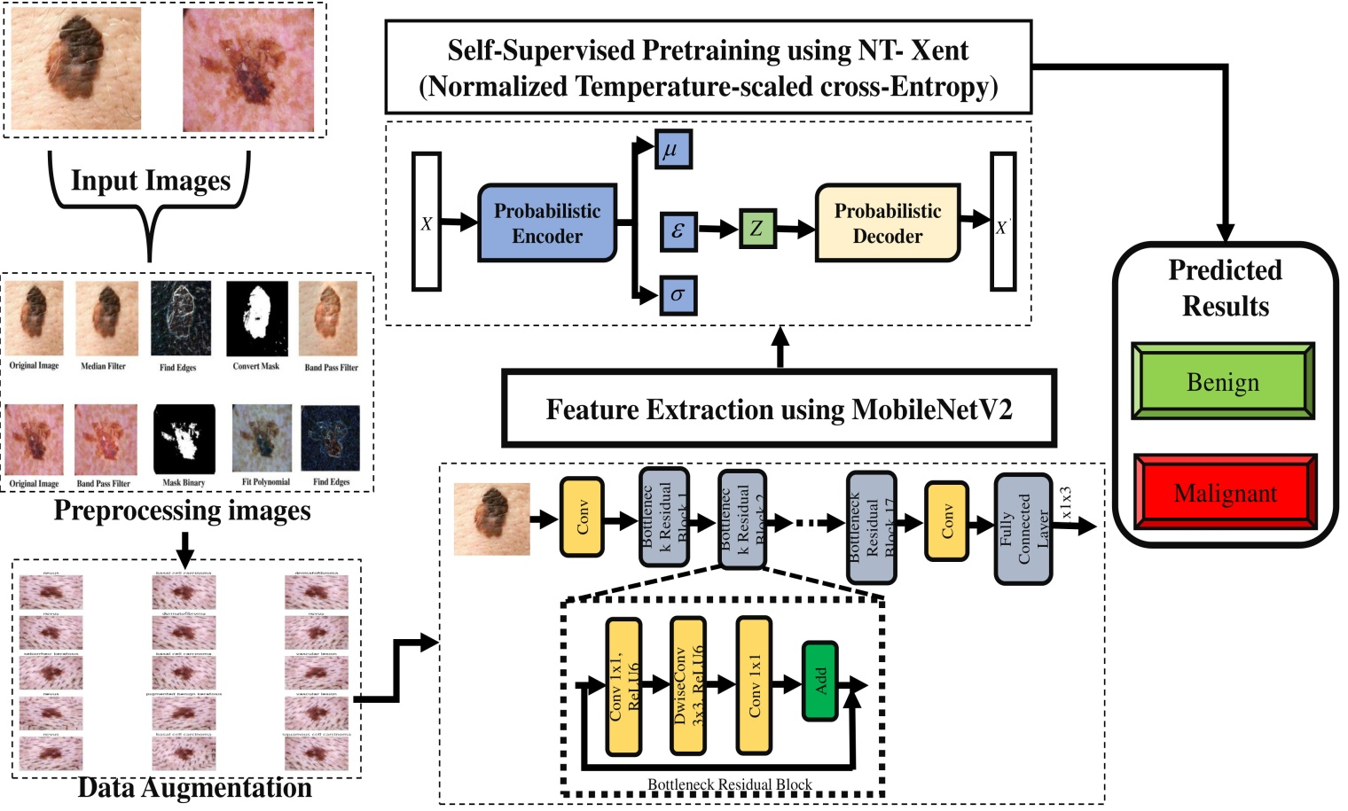
Figure 1. The block diagram of proposed model
3.1 Dataset
3.1.1 ISIC 2019 Dataset
The ISIC 2019 Challenge Dataset focuses on SC diagnosis and is a large and diverse collection [14]. It comprises 25,331 dermoscopic images spanning eight detection categories: melanoma, BCCa, actinic keratosis, benign keratosis, DF, VASC, SCCa, and nevi. These images are sourced from multiple international clinical facilities to ensure diversity in patient demographics and acquisition conditions. The dataset presents a multi-class image classification problem, as each image is associated with a specific ground truth diagnosis. Notably, the dataset is highly imbalanced, with the most common class being "nevus" (NV) and relatively fewer samples in certain malignant categories such as DF and VASC. Due to its extensive scope and clinical relevance, the ISIC 2019 dataset serves as an important benchmark for developing and estimating DL models in automated SC diagnosis. Figure 2 presents an overview of the ISIC 2019 dataset.
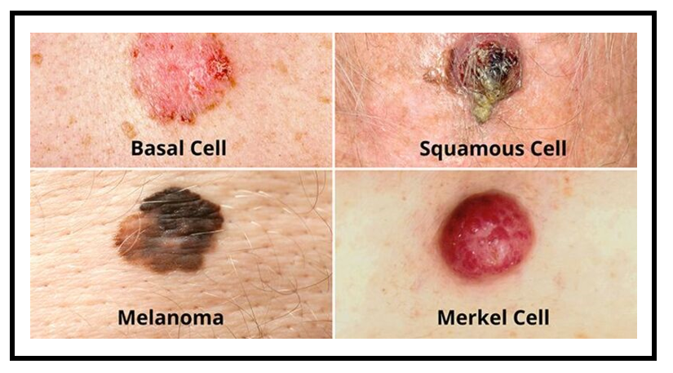
Figure 2 The ISIC 2019 dataset.
3.1.2 HAM10000 Dataset
The extensive and varied HAM10000 ("Human Against Machine with 10,000 training images") dataset is intended for machine learning studies in dermatology, particularly in the area of SC classification [15]. A total of 10,015 dermatoscopic images were gathered from various demographic and clinical sources. A total of 6,705 melanocytic nevi (NV), 1,113 MEL, 1,099 benign keratosis-like lesions (BKL), 514 BCC, 327 actinic keratoses and intraepithelial carcinoma (AKIEC), 142 VASC, and 115 DF images are included in the collection. When creating and assessing DL systems for automated SC detection, the HAM10000 dataset offers a useful baseline. The HAM10000 dataset is displayed in Figure 3, and the class distribution within the dataset is displayed in Figure 4.
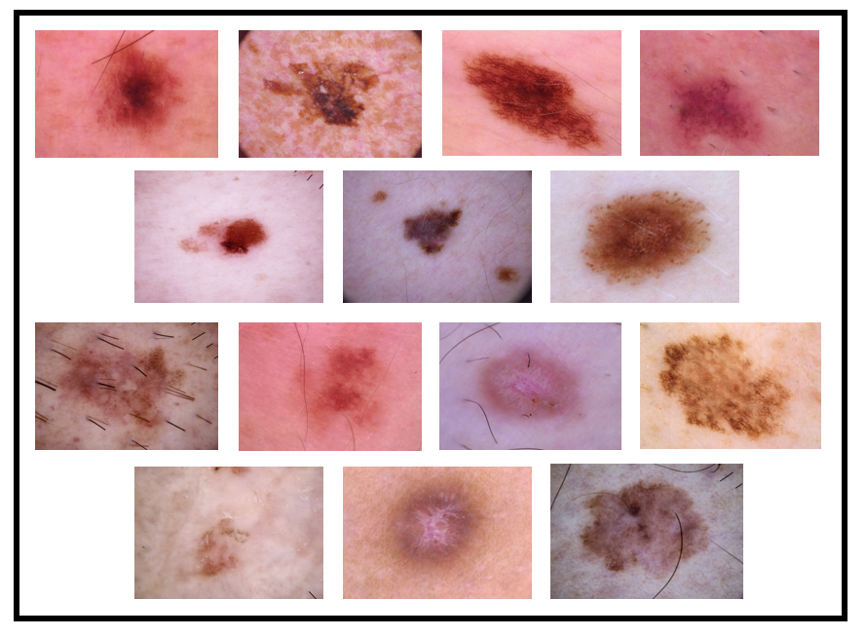
Figure 3 The HAM10000 dataset
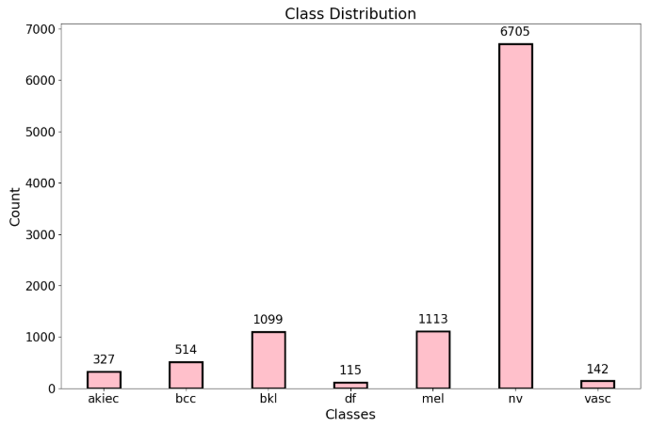
Figure 4 Class distribution in the HAM10000 dataset
3.2 Pre-processing using DullRazor
Pre-processing is an essential step in the SC detection pipeline, as it enhances image quality and ensures accurate lesion segmentation [16]. Hair artifacts container obscure important features of SC, posing a significant challenge in dermoscopic images. To address this issue, the DullRazor algorithm is employed as a hair removal pre-processing technique. The DullRazor method comprises three main stages: detection, interpolation, and smoothing. Figure 5 illustrates the pre-processing images used in the proposed method.
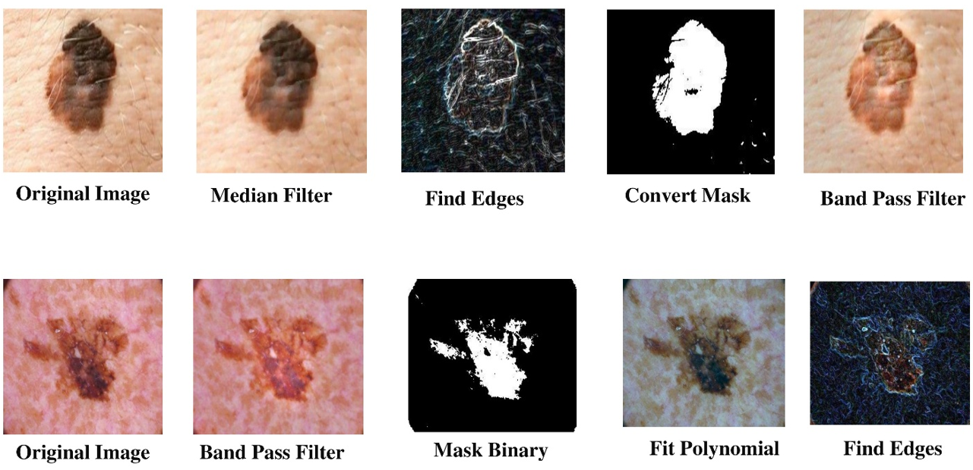
Figure 5: Pre-processing images for proposed method
The grayscale image $I(x,y)$ is first subjected to a morphological closure operation to highlight narrow, dark structures in order to detect hair pixels. Morphological closing is mathematically expressed as:
$I_{closed}​(x,y)=(I(x,y)⊕B)⊖B$ (1)
Where $⊕$ denotes dilation, $⊖$ denotes erosion, and $B$ is a structuring element (typically a small disk or line shape matching hair thickness). Next, a hair mask $M(x,y)$ is generated by thresholding the closed image:
$M\left(x,y\right)=\left\{\begin{aligned}1, ifI_{closed}\left(x,y\right)<T \\ 0, otherwise\end{aligned}\right.$ (2)
Where $T$ is an empirically chosen intensity threshold. This binary mask identifies the hair-affected regions. After detecting these regions, bilinear interpolation is utilized to fill in the missing pixel values based on the surrounding non-hair pixels. For any hair pixel at location$(x,y)$, the interpolated intensity $I_{interp}\left(x,y\right)$can be computed as:​
$I_{interp}\left(x,y\right)=\frac{1}{|N|}\sum_{\left(i,j\right)∈N}{I\left(i,j\right)}$ (3)
Wherever $N$ signifies the set of neighboring non-hair pixels around$(x,y)$. Finally, to eliminate abrupt transitions and restore the natural skin texture, a smoothing filter typically a Gaussian filter is added to the interpolated image. The Gaussian smoothing is mathematically expressed as:
$I_{smooth}\left(x,y\right)=I_{interp}\left(x,y\right)*G\left(x,y,σ\right)$ (4)
Where $G(x,y,σ)$ is the Gaussian kernel with standard deviation $σ$, and $*$ denotes convolution. Through DullRazor-based pre-processing, dermoscopic images are effectively cleaned, improving lesion visibility and improving the accuracy of downstream DL models for SC detection.
3.3 Contrastive pretraining with data augmentations
Data augmentation is needed for improving model generalization in DL-based SC diagnosis, especially when the dataset is small or imbalanced. The system is exposed to a wider variety of characteristics and SC appearances by modifying the training data in order to artificially increase its size [17]. Figure 6 illustrates the data augmentation used in the proposed method.
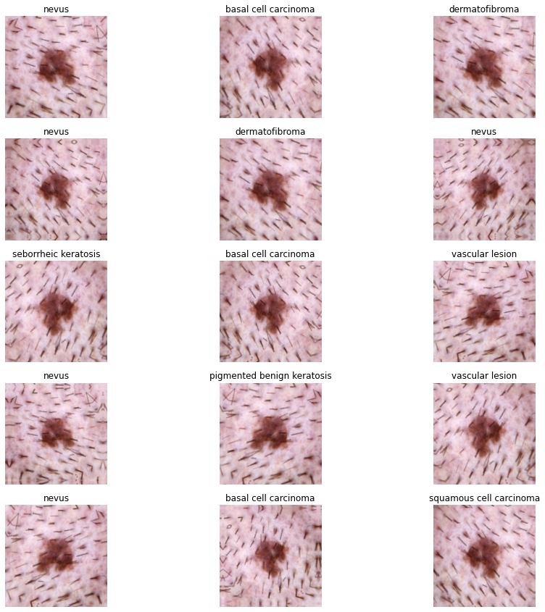
Figure 6: Data Augmentation for proposed method
This decreases the risk of overfitting and enhances robustness to real-world variations such as lighting conditions, skin tones, lesion shapes, and orientations. Mathematically, a data augmentation function can be denoted as:
$x^{'}=T\left(x\right)$ (5)
Wherever x is the original image, $x^{'}$ is the augmented image, and $T(⋅)$ signifies a transformation function such as rotation, flipping, scaling, or color jittering. For instance, random rotations by an angle$θ∈\left[-{30}^{°},+{30}^{°}\right]$, horizontal/vertical flipping, and Gaussian noise addition are commonly applied to dermoscopic images to simulate different acquisition conditions. Another common strategy is to apply a composition of transformations sequentially:
$x^{'}=T_{n}\left(T_{n-1}\left(…T_{2}\left(T_{1}\left(x\right)\right)…\right)\right)$ (6)
Multiple augmentations, including contrast enhancement, resizing, and elastic deformations, can be stacked using this composite formulation to replicate the inherent variety of skin texture. These augmentations are crucial in self-supervised and contrastive learning pipelines, where meaningful feature representations must be learned from unlabelled or weakly labelled dermoscopy datasets.
3.4 Feature Extraction using MobileNetV2
MobileNetV2 is a low-power deep neural network architecture designed for mobile and embedded vision requests. It incorporates two significant innovations: depthwise separable convolutions to reduce computational cost and inverted residual blocks with linear bottlenecks to increase representational efficiency [18]. By dividing the convolution into a depthwise convolution and a pointwise convolution, MobileNetV2 significantly reductions the number of calculations when compared to traditional convolutional layers. The standard convolutional cost for an input with $M$ channels, output with $N$ channels, a kernel size of $k×k$, and spatial size $D_{f}×D_{f}$ is:
${Cost}_{standard}=D_{k}×D_{k}×M×N×D_{f}×D_{f}$ (7)
While the depthwise separable convolution cost becomes:
${Cost}_{depthwise separable}=D_{k}×D_{k}×M×D_{f}×D_{f}+M×N×D_{f}×D_{f}$ (8)
This results in a significant reduction in computation, especially when $k$ is small (typically 3). A key contribution of MobileNetV2 is the inverted residual block. While traditional residual connections map from high-dimensional to low-dimensional spaces, MobileNetV2 'inverts' this process by first expanding the number of channels, processing them, and then compressing back to a compact representation. Formally, given an input tensor $x$, the expansion operation uses a $1×1$ convolution:
$z=σ\left(W_{e}x\right)$ (9)
Where $W_{e}$​ is the weight matrix for expansion and $σ$ is a non-linear activation function (ReLU6). The depthwise convolution then applies a spatial filter:
$d=σ(D(z))$ (10)
Where $D$ represents the depthwise convolution operation. Finally, a linear bottleneck projection compresses the channels back with another $1×1$ convolution without non-linearity:
$y=W_{p}d$ (11)
Where $W_{p}$​ is the projection weight matrix. The linear bottleneck is crucial in MobileNetV2 to prevent information loss. When the output dimensions are small, applying a non-linearity (such as ReLU) can lead to information collapse by zeroing out important features. Therefore, MobileNetV2 employs a purely linear transformation at the bottleneck. If the input and output dimensions match, a shortcut connection (residual addition) is applied.
$y=x+W_{p}D\left(σ\left(W_{e}x\right)\right)$ (12)
Otherwise, if the dimensions differ (e.g., due to a stride of 2 for downsampling), the residual connection is omitted. This enables MobileNetV2 to maintain both high information fidelity and computational efficiency. Overall, MobileNetV2 significantly improves mobile and embedded vision systems by delivering high accuracy at a low computational cost. With its efficient depthwise separable convolutions and the inverted residual with linear bottleneck strategy, MobileNetV2 achieves strong performance on tasks such as image cataloguing, objective diagnosis, and semantic segmentation, using far fewer parameters and lower FLOPs compared to traditional deep CNNs. These design principles have influenced many subsequent architectures, making MobileNetV2 a milestone in the field of lightweight deep learning models.
3.5 Self-Supervised Pretraining using NT-Xent
A popular contrastive loss function in self-supervised learning frameworks like SimCLR is the NT-Xent. By pushing changed samples (negative pairs) apart and bringing similar samples (positive pairs) closer together in the embedding space, it encourages representation learning. Formally, consider a minibatch containing $N$ original samples, each augmented twice, leading to $2N$ views. Let $z_{i}$ and $z_{j}$​ represent the standardized embeddings of two augmented views from the same original image, forming a positive pair. The cosine similarity amongst two embeddings $z_{i}$ and $z_{j}$​ is computed as:
$sim\left(z_{i},z_{j}\right)=\frac{z_{i}^{⊤}z_{j}}{\left|\left|z_{i}\right|\right| |\left|z_{j}\right||}$ (13)
Where $∥⋅∥$ denotes the Euclidean norm, ensuring that the embeddings are unit vectors$\left(\left|\left|z_{i}\right|\right|=1\right)$. The NT-Xent loss for a positive pair $(i,j)$ is definite as:
$l\left(i,j\right)=-log\frac{exp\left(sim\left(z_{i},z_{j}\right)/τ\right)}{\sum_{k=1}^{2N}{1_{\left[k≠i\right]}exp\left(sim\left(z_{i},z_{k}\right)/τ\right)}}$ (14)
In the NT-Xent loss formulation, $τ>0$ is the temperature scaling hyperparameter that adjusts the sharpness of the similarity distribution; a lower $τ$ makes the model focus more strongly on harder negatives by sharpening the distribution, while a higher $τ$ leads to a smoother, more uniform weighting. The term $1_{\left[k≠i\right]}$represents an indicator function that ensures the similarity of a sample with itself is excluded from the denominator during normalization, preventing trivial solutions and ensuring that only true negatives and the positive pair are considered in the contrastive learning process. Expanding further, the numerator promotes similarity between the positive pair $(i,j)$, while the denominator aggregates similarities with all other $2N-1$ examples (including j and all negatives). The total NT-Xent loss over the entire batch is averaged across all positive pairs:
$L=\frac{1}{2N}\sum_{k=1}^{N}{\left(l\left(2k-1,2k\right)+l\left(2k,2k-1\right)\right)}$ (15)
This symmetric formulation ensures that both directions of positive pairs are accounted for (i.e., $(i,j)$ and $(j,i)$). For computational efficiency, the pairwise similarities across the batch are typically stored in a similarity matrix$S∈R^{2N×2N}$, where:
$S_{i,j}=\frac{z_{i}^{⊤}z_{i}}{τ}$ (16)
Allowing efficient vectorized operations during loss computation. Importantly, the use of a temperature parameter $τ$ sharpens or flattens the similarity distribution: The temperature limitation $τ$ in NT-Xent loss plays a critical role in controlling the sharpness of the similarity distribution. When $τ$ is small (i.e., $τ<1$), the softmax function becomes sharper, causing the model to focus more heavily on distinguishing harder negative samples. In contrast, a large $τ$ value smoothens the softmax distribution, leading the model to treat all negatives more uniformly without overly emphasizing the hardest ones. Thus, adjusting $τ$ directly affects the model's sensitivity to challenging negatives during representation learning. Finally, the softmax normalization over negatives ensures that NT-Xent can be interpreted as a form of cross-entropy loss between the true pair and the softmax probabilities over all candidates:
$SoftmaxProb\left(i,j\right)=\frac{exp\left(sim\left(z_{i},z_{j}\right)/τ\right)}{\sum_{k=1}^{2N}{1_{\left[k≠i\right]}exp\left(sim\left(z_{i},z_{k}\right)/τ\right)}}$ (17)
Therefore, by optimizing the agreement among various enhanced views of the same instance while contrasting them with other examples in the batch, NT-Xent efficiently enables the model to learn strong and discriminative demonstrations since unlabeled data.
3.6 Advantage of proposed model
- MobileNetV2 offers a lightweight architecture with depthwise separable convolutions, reducing computational cost and memory usage while maintaining high representational power ideal for medical imaging tasks with limited resources.
- Using NT-Xent loss enables contrastive pretraining without the need for large-scale labeled datasets, making the model more data-efficient and better at learning robust features from dermoscopic images.
- The application of the DullRazor algorithm removes hair artifacts from skin lesion images, enhancing lesion visibility and reducing noise, which leads to improved feature extraction and higher diagnostic accuracy.
4. Result and Discussion
The suggested method's efficacy is estimated using the images from the HAM10000 and ISIC 2019 datasets. We investigated this using a high-performance Linux server running Ubuntu 22.04. The technique made use of modern tools including an Intel i9-14900K CPU, 64 GB of DDR5 RAM, and an NVIDIA RTX 490 GPU. For comparison, state-of-the-art methods such MASK-RCNN [22], RCNN [21], VGG16 [20], and SCSO-ResNet50 [19] are used. Using measures of precision (P), recall (R/sensitivity (S), F-score (F-S), accuracy (A), Matthews correlation coefficient (MCC), false alarm rate (FAR), specificity (Sp), and computing time (CT), the proposed MobileNetV2-NT-Xent segmentation method is evaluated. Specificity is the ratio of non-lesion pixels incorrectly identified as SC; recall is the proper cataloguing of SC pixels; and accuracy offers a general assessment of pixel-level detection performance. Performance metrics including FN, FP, TP, and TN allow one to assess the effectiveness of melanoma detection strategies even further Recall reflects the capability to correctly identify SC lesion data, specificity represents the proportion of correctly recognized non-lesion SC data, and accuracy is widely used to assess the overall classification performance, as illustrated below.
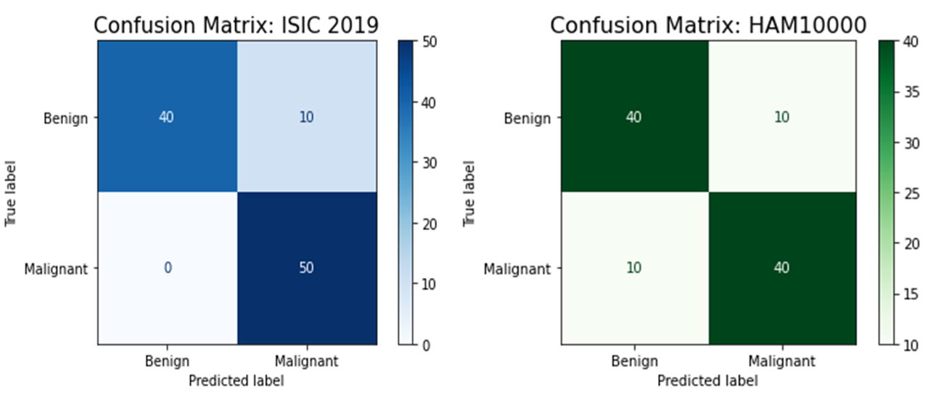
Figure 7: Confusion matrix analysis for ISIC 2019 and HAM10000 datasets
Fig. 7 shows the confusion matrices displaying the classification performance of the proposed MobileNetV2-NT-Xent approach on the ISIC 2019 and HAM10000 skin cancer datasets. For the ISIC 2019 dataset, the method accurately detected 40 benign and 50 malignant cases, with only 10 benign samples misclassified as malignant, indicating high precision and recall for malignant identification. In comparison, the model’s accuracy and sensitivity on the HAM10000 dataset were slightly lower. It correctly identified 40 benign and 40 malignant cases but misclassified 10 benign as malignant and 10 malignant as benign. Overall, both confusion matrices demonstrate strong classification accuracy, with the ISIC 2019 dataset showing marginally better performance. Fig.8 shows the final prediction images.

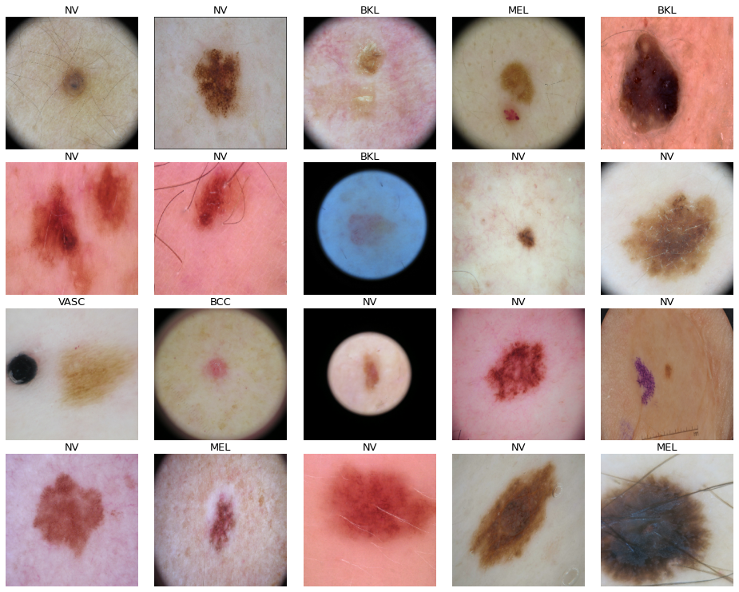
Figure 8: Final prediction Images
Precision (P) indicates how many of the forecast positive results are actually accurate. It emphasizes the accuracy of positive predictions.
$Precision=\frac{TP}{TP+FP}$ (18)
Recall (R) indicates how many actual positives were accurately detected by the model. It focusses on catching all potential positives.
$Recall=\frac{TP}{TP+FN}$ (19)
The F-Score (F-S), which is the harmonic mean of precision and recall, offers a balanced measure of both. It is particularly useful when there is a need to balance FP and FN.
$F-Score=2×\frac{Precision×Recall}{Precision+Recall}$ (20)
Accuracy (A) measures the percentage of correct positive and negative forecasts out of the overall number of forecasts, thereby evaluating the total correctness of the model.
$Accuracy=\frac{TP+TN}{TP+TN+FP+FN}$ (21)
A binary classification quality statistic, the MCC considers the four confusion matrix categories (TP, TN, FP, and FN). When there are unequal classes, it provides a fair assessment.
$MCC=\frac{TP×TN-FP×FN}{\sqrt{\left(TP+FP\right)\left(TP+FN\right)\left(TN+FP\right)\left(TN+FN\right)}}$ (22)
Specificity (Sp) is the percentage of actual negatives acceptably recognized as negative by the model. It focuses on how effectively the model avoids false positives.
$Specificity=\frac{TN}{TN+FP}$ (23)
False Alarm Rate (FAR) calculates the percentage of negative cases that are incorrectly recognized as positives. It is widely used in biometric systems to determine how frequently unauthorized users are mistakenly accepted.
$FAR=\frac{FP}{FP+TN}$ (24)
Computational Time (CT) denotes to the total time required for a model or system to process data and produce a result, from input to output.
$Computational Time=End Time-Start Time$ (25)
Table 2: Comparative Analysis for ISIC 2019 and HAM10000 Dataset
Models | Dataset
Models | ISIC 2019 |  |  |  |  |  | HAM10000
Models | Performance Metrics |  |  |  |  |  | Performance Metrics
Models | P | R | F-S | A | Sp | MCC | P | R | F-S | A | Sp | MCC
SCSO-ResNet50 | 76.34 | 64.29 | 77.88 | 87.34 | 67.34 | 75.87 | 78.29 | 78.39 | 65.19 | 89.67 | 65.29 | 73.29
VGG16 | 81.45 | 76.22 | 70.33 | 80.11 | 78.33 | 79.87 | 80.33 | 81.76 | 76.37 | 90.34 | 76.48 | 79.76
RCNN | 89.55 | 70.87 | 65.18 | 89.44 | 80.44 | 86.22 | 85.39 | 80.77 | 81.98 | 93.98 | 87.22 | 81.87
MASKRCNN | 90.22 | 88.22 | 84.56 | 94.65 | 85.22 | 90.22 | 89.11 | 87.28 | 86.44 | 95.98 | 90.66 | 91.65
Proposed | 93.56 | 93.65 | 95.34 | 98.98 | 96.18 | 92.87 | 93.98 | 92.98 | 95.87 | 98.76 | 96.12 | 94.67
A comparison of how several models are presented on the ISIC 2019 and HAM10000 datasets is presented in Table 2 and Figure 9. The table shows the performance metrics Precision, Recall, F-Score, Accuracy, Specificity, and MCC for five models: SCSO-ResNet50, VGG16, RCNN, MASKRCNN, and the suggested technique. For the ISIC 2019 dataset, the suggested method outperforms all others across all metrics, succeeding the highest Precision (93.56%), Recall (93.65%), F-Score (95.34%), Accuracy (98.98%), Specificity (96.18), and MCC (92.87). The MASKRCNN model follows closely with high Precision (90.22%), Recall (88.22%), F-Score (84.56%), and Accuracy (94.65%). The RCNN model also demonstrates solid performance, particularly in terms of Accuracy (89.44%) and MCC (86.22%), although it lags behind the top performers on some other metrics. On the HAM10000 dataset, the proposed model again achieves the best results in all metrics: Precision (93.98%), Recall (92.98%), F-Score (95.87%), Accuracy (98.76%), Specificity (96.12%), and MCC (94.67%). The MASKRCNN model also maintains strong performance, closely approaching the suggested method. These results indicate that, while the models perform relatively consistently across both datasets, the suggested method consistently delivers the best overall presentation in terms of precision, robustness, and general reliability across all evaluation criteria.
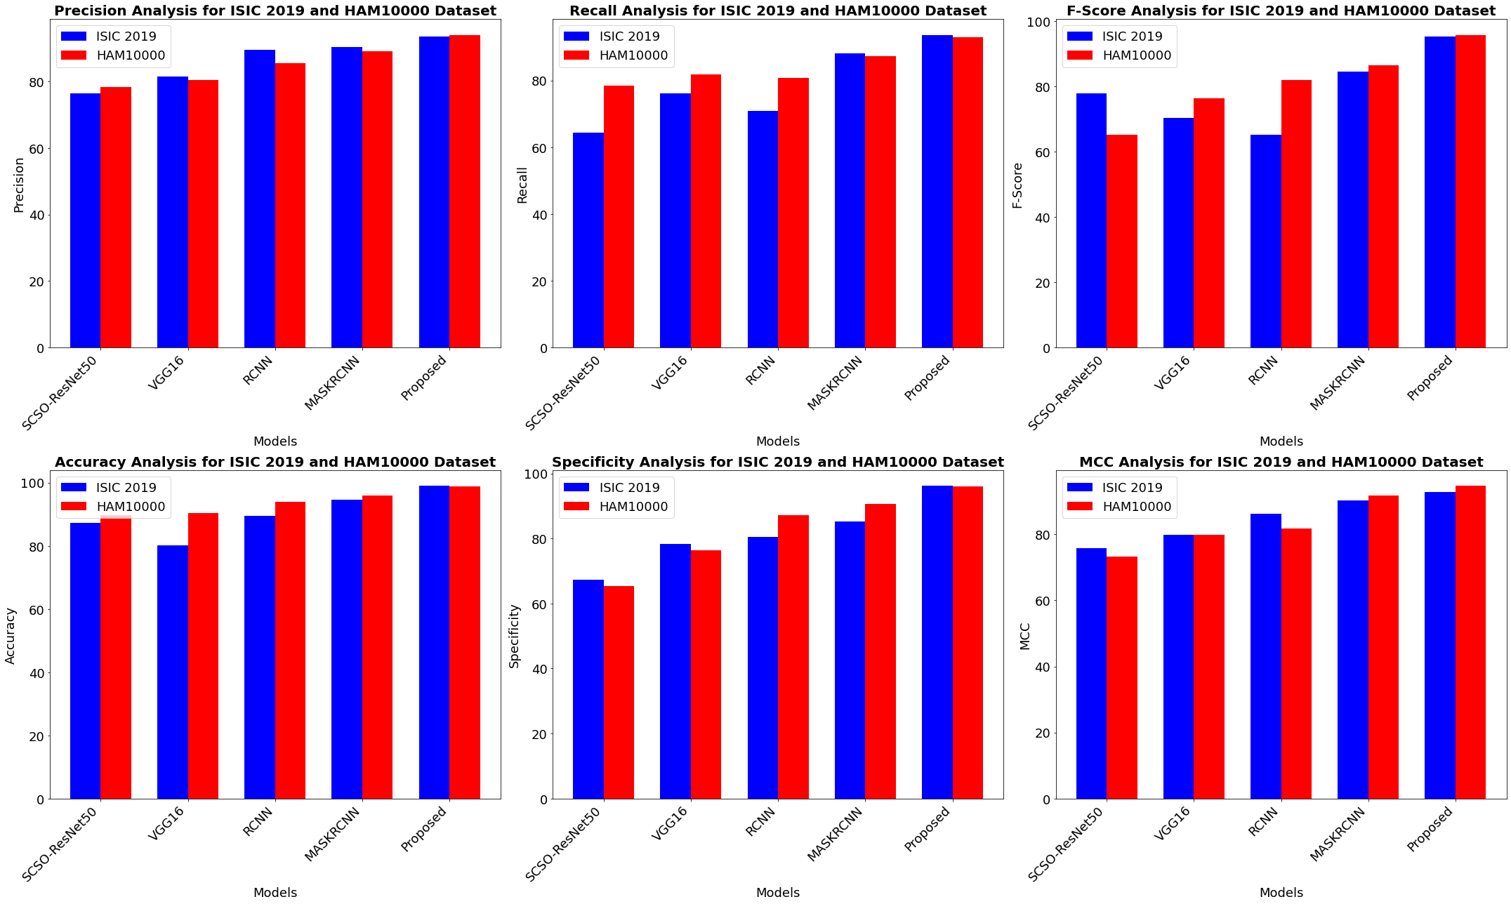
Figure 9: Comparative Analysis for ISIC 2019 and HAM10000 Dataset
Table 3: FAR Analysis for proposed method
Models | Dataset
Models | ISIC 2019 | HAM10000
Models | Performance Metrics
Models | FAR
SCSO-ResNet50 | 33.29 | 29.98
VGG16 | 30.18 | 31.87
RCNN | 27.45 | 27.87
MASKRCNN | 27.88 | 28.87
Proposed | 20.76 | 25.18
The FAR analysis of multiple models utilizing the ISIC 2019 and HAM10000 datasets is shown in Table 3 and Figure 10. The recommended approach obtained the lowest FAR values (20.76% for the ISIC 2019 dataset and 25.18% for the HAM10000 dataset) among the models that were compared. Higher FARs were demonstrated by established models like SCSO-ResNet50, VGG16, RCNN, and MASKRCNN. On the HAM10000 and ISIC 2019 datasets, VGG16 demonstrated FARs of 31.87% and 30.18%, respectively, while SCSO-ResNet50 reported FARs of 33.29% and 29.98%. With FAR values varying between 27% and 28% throughout both datasets, the RCNN and MASKRCNN systems demonstrated a modest level of performance. Overall, the proposed approach outperformed standard models by significantly reducing the FAR, thereby improving classification reliability and minimizing the incidence of false positive predictions.
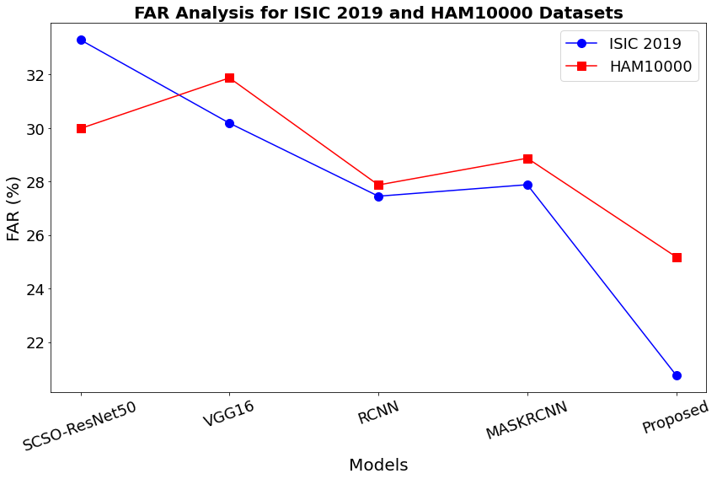
Figure 10: FAR Analysis for proposed method
Table 4: Computational Time Analysis for proposed method
Models | Dataset
Models | ISIC 2019 | HAM10000
Models | Performance Metrics
Models | Computational Time
SCSO-ResNet50 | 10.433 | 8.198
VGG16 | 7.344 | 6.615
RCNN | 5.176 | 10.551
MASKRCNN | 3.118 | 6.345
Proposed | 1.654 | 3.265
Table 4 and Figure 11 illustrate the computational time analysis of various models on the ISIC 2019 and HAM10000 datasets. The suggested technique achieved the shortest computation times, requiring only 1.654 seconds for ISIC 2019 and 3.265 seconds for HAM10000. In comparison, SCSO-ResNet50 exhibited significantly longer computation times of 10.433 and 8.198 seconds, respectively. Similarly, VGG16 required 7.344 seconds on ISIC 2019 and 6.615 seconds on HAM10000, while RCNN took 5.176 seconds and 10.551 seconds, respectively. MASK-RCNN performed better than the existing models, although it still required 3.118 seconds and 6.345 seconds on the two datasets. Overall, the proposed method significantly reduced computational time across both datasets, demonstrating its efficiency and suitability for real-time or resource-constrained applications.
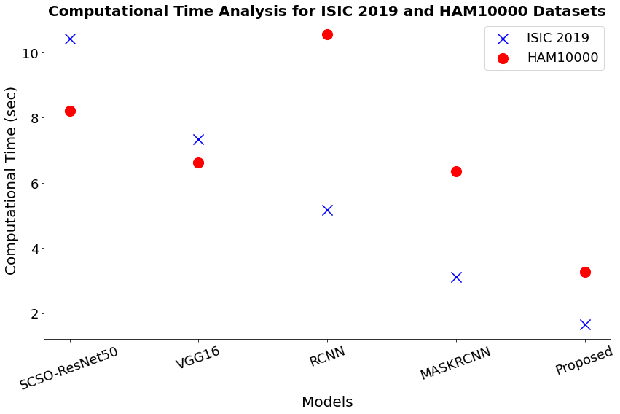
Figure 11: Computational Time Analysis for proposed method
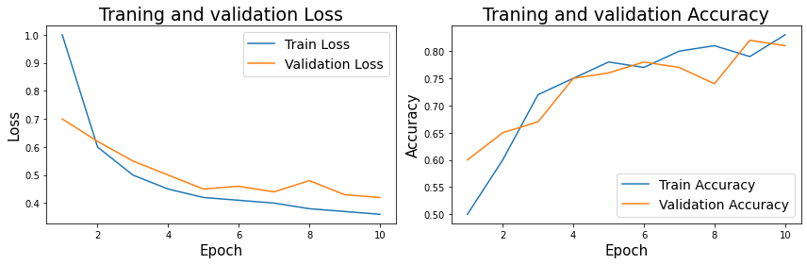
Figure 12: Training and Testing Validation Loss and Accuracy
Figure 12 shows the training and validation performance of a DL model across 10 epochs using two crucial metrics: accuracy and loss. On the left side of the graph are shown the training and validation loss curves. In the first epochs, the training loss fast drops; subsequently, it steadily stabilizes, signifying fast learning. The validation loss follows a similar trend with a minor indication of overfitting or data variance past the sixth epoch. Over time, the training and validation accuracy curves on the right exhibit a persistent rising tendency. From their starting value of 0.75 to over 0.9 at the end of the century, the training and validation accuracies have been rising gradually.
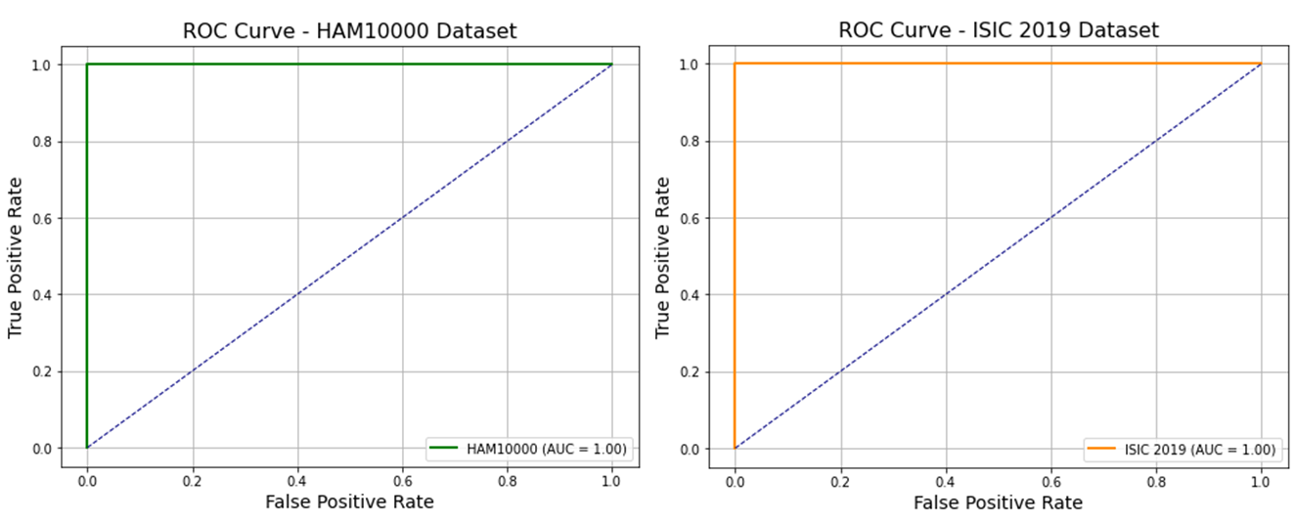
Figure 13: Roc curve analysis for two datasets
On the HAM10000 and ISIC 2019 skin cancer datasets, the proposed MobileNetV2-based self-supervised learning method is shown by the ROC curves in Figure 13. As they approach the upper-left corner of the plot, the ROC curves for both designs exhibit outstanding classification performance. The Area Under the Curve (AUC) of 1.00 suggests perfect sensitivity and specificity in the datasets. By proving its capacity to accurately distinguish benign from malignant tumors, this shows the dependability and resilience of the model for real medical diagnosis.
4.1 Discussion
The efficacy of the suggested MobileNetV2-based self-supervised learning model for SC identification, which includes NT-Xent contrastive loss and DullRazor artefact removal, is established by the experimental results. When tested against well-known models including SCSO-ResNet50, VGG16, RCNN, and MASKRCNN, the suggested approach beats all evaluation criteria on both the ISIC 2019 and HAM10000 datasets. Maximum accuracy of 98.98% and 98.76% precisions of 93.56% and 93.98%, recalls of 93.65% and 92.98%, F1-scores of 95.34% and 95.87%, specificities of 96.18% and 96.12%, and MCCs of 92.87 and 94.67, respectively were obtained by the proposed technique. Moreover, the suggested method considerably outperformed the baseline models with greater False Acceptance Rate (FAR) at 20.76% (ISIC 2019) and 25.18% ( HAM10000). Additionally, computational efficiency is a notable advantage, with the proposed model requiring only 1.654 seconds (ISIC 2019) and 3.265 seconds (HAM10000), outperforming SCSO-ResNet50 (10.433s and 8.198s) and even MASKRCNN (3.118s and 6.345s). The ablation study validates the contributions of each component: NT-Xent contrastive learning alone boosts accuracy to 95.55%, and when combined with DullRazor preprocessing, performance is maximized at 98.87%. These outcomes establish the suggested model’s robustness, accuracy, and efficiency, highlighting its suitability for real-time and mobile healthcare requests.
4.2 Ablation Study
Table 5: Ablation Study for Accuracy Analysis
Model Variant | Pre-processing (DullRazor) | Contrastive Learning (NT-Xent) | Fine-Tuning | Accuracy (%)
MobileNetV2 (Supervised Only) | ✖ | ✖ | ✔ | 87.54
MobileNetV2 + DullRazor (Supervised Only) | ✔ | ✖ | ✔ | 80.17
MobileNetV2 + NT-Xent (Without DullRazor) | ✖ | ✔ | ✔ | 95.55
MobileNetV2 + DullRazor + NT-Xent (Proposed) | ✔ | ✔ | ✔ | 98.87
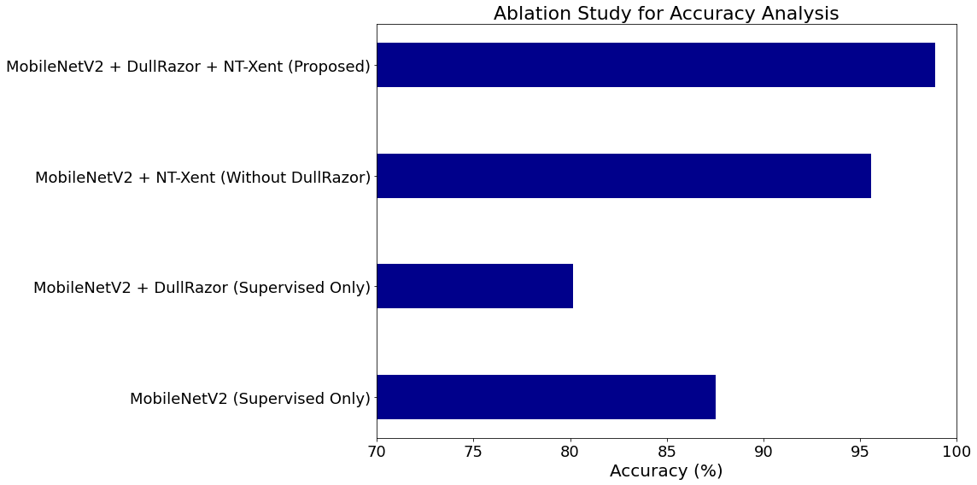
Figure 14: Ablation Study for Accuracy Analysis
Table 5 and Figure 14 present an ablation study that examines the impact of various components on model accuracy. The study compares different MobileNetV2 configurations, considering the effects of pre-processing (DullRazor), contrastive learning (NT-Xent), and fine-tuning. The top row shows the baseline performance of MobileNetV2 trained solely with supervised learning, which achieved an accuracy of 87.54%. When DullRazor pre-processing is applied without contrastive learning, the accuracy drops to 80.17%, highlighting the importance of the contrastive learning phase. Conversely, using NT-Xent contrastive learning without DullRazor results in a significantly higher accuracy of 95.55%, demonstrating the efficiency of contrastive learning in augmenting model performance. Finally, the proposed model, which incorporates DullRazor pre-processing, NT-Xent contrastive learning, and fine-tuning, achieves the highest accuracy of 98.87%, confirming that all components synergistically contribute to improved model performance.
Table 6: Comparison of the proposed method with the state-of-the-art methods for accuracy analysis
Ref | Dataset | Model | Preprocessing | Accuracy
[23] | HAM10000 | CNN transfer learning | Yes | 87.9%
[24] | HAM10000 | Modified Efficient Net | Yes | 95.95
[25] | HAM10000 | VGG19 | Yes | 86%
[26] | HAM10000 | ResNet-50+VGG-16 | Yes | 94.14%.
[27] | HAM10000 | ViTs (RGB images) | Yes | 92.14%
[28] | HAM10000 | Entropy-NDOELM algorithm | Yes | 95.7%
Our Model | ISIC 2019, HAM10000 | MobileNetV2-NT-Xent | - | 98.87%
A comparative accuracy analysis of the suggested MobileNetV2-NT-Xent method versus a number of cutting-edge techniques for SC detection is presented in Table 6 and Figure 15. The suggested technique succeeds the highest accuracy of 98.87% using combined datasets (ISIC 2019, HAM10000), without any explicitly stated preprocessing steps. This performance significantly surpasses previous methods such as CNN transfer learning ([23], 87.9%), Modified EfficientNet ([24], 95.95%), VGG19 ([25], 86%), ResNet-50+VGG-16 ensemble ([26], 94.14%), Vision Transformers using RGB images ([27], 92.14%), and the Entropy-NDOELM algorithm ([28], 95.7%). The substantial improvement in accuracy highlights the effectiveness of integrating contrastive self-supervised learning (NT-Xent loss) with the lightweight MobileNetV2 architecture, demonstrating its potential for highly accurate and efficient real-time skin lesion diagnosis.
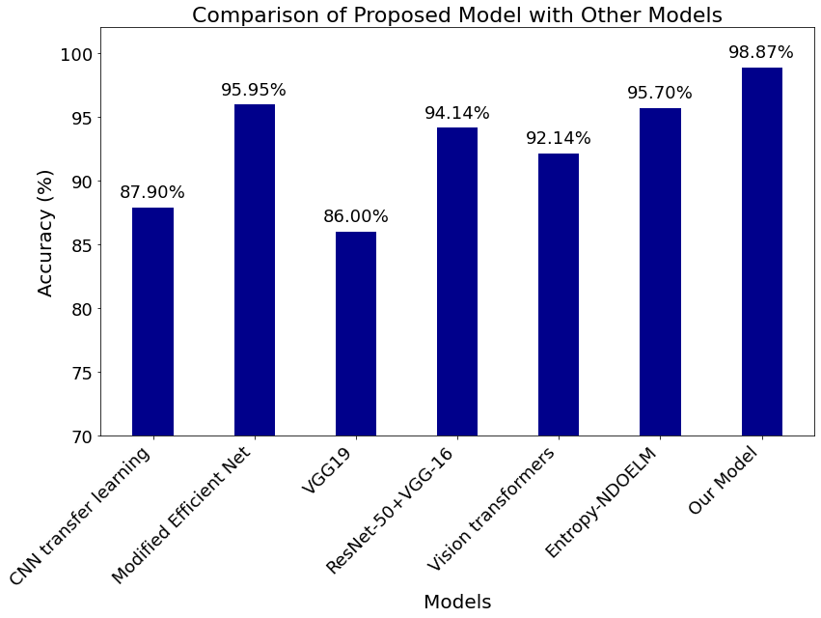
Figure 15: Comparison of the proposed model with other models
5. Conclusion
In conclusion, the MobileNetV2-based self-supervised model with NT-Xent loss and DullRazor artefact removal makes a significant contribution to SC identification. This method successfully lessens the dependency on sizable labeled datasets by utilizing the capability of self-supervised learning, which increases its adaptability and scalability for real-world situations. While DullRazor artefact reduction improves image quality by reducing the influence of noise and artefacts, NT-Xent loss increases the model's capability to learn discriminative features since unlabeled data. The results demonstrate that this framework has the potential to deliver accurate, efficient, and reliable SC detection, with promising implications for improving early diagnosis and treatment outcomes. Future research could explore integrating additional medical imaging modalities and enhancing the model's robustness across diverse datasets.
References
- Mijwil, M. M. (2021). Skin cancer disease images classification using deep learning solutions. Multimedia Tools and Applications, 80(17), 26255-26271. https://doi.org/10.1007/s11042-021-10952-7
- Kumar, M., Alshehri, M., AlGhamdi, R., Sharma, P., & Deep, V. (2020). A de-ann inspired skin cancer detection approach using fuzzy c-means clustering. Mobile Networks and Applications, 25, 1319-1329. https://doi.org/10.1007/s11036-020-01550-2
- Wei, L., Ding, K., & Hu, H. (2020). Automatic skin cancer detection in dermoscopy images based on ensemble lightweight deep learning network. IEEE Access, 8, 99633-99647. https://doi.org/10.1109/ACCESS.2020.2997710
- Vijayalakshmi, D., & Nath, M. K. (2023). A systematic approach for enhancement of homogeneous background images using structural information. Graphical Models, 130, 101206. https://doi.org/10.1016/j.gmod.2023.101206
- Luo, S., & Shaukat, K. (Eds.). (2022). Computational methods for medical and cyber security. MDPI Books. https://doi.org/10.3390/books978-3-0365-5115-9
- Ali, Z., Hayat, M. F., Shaukat, K., Alam, T. M., Hameed, I. A., Luo, S., ... & Ksibi, A. (2022). A proposed framework for early prediction of schistosomiasis. Diagnostics, 12(12), 3138. https://doi.org/10.3390/diagnostics12123138
- Shaukat, K., Luo, S., Varadharajan, V., Hameed, I. A., Chen, S., Liu, D., & Li, J. (2020). Performance comparison and current challenges of using machine learning techniques in cybersecurity. Energies, 13(10), 2509. https://doi.org/10.3390/en13102509
- Siddique, A., Shaukat, K., & Jan, T. (2024). An intelligent mechanism to detect multi-factor skin cancer. Diagnostics, 14(13), 1359. https://doi.org/10.3390/diagnostics14131359
- Ogundokun, R. O., Li, A., Babatunde, R. S., Umezuruike, C., Sadiku, P. O., Abdulahi, A. T., & Babatunde, A. N. (2023). Enhancing skin cancer detection and classification in dermoscopic images through concatenated MobileNetV2 and xception models. Bioengineering, 10(8), 979. https://doi.org/10.3390/bioengineering10080979
- Naeem, A., Anees, T., Khalil, M., Zahra, K., Naqvi, R. A., & Lee, S. W. (2024). SNC_Net: skin cancer detection by integrating handcrafted and deep learning-based features using dermoscopy images. Mathematics, 12(7), 1030. https://doi.org/10.3390/math12071030
- Nigar, N., Umar, M., Shahzad, M. K., Islam, S., & Abalo, D. (2022). A deep learning approach based on explainable artificial intelligence for skin lesion classification. IEEE Access, 10, 113715-113725. https://doi.org/10.1109/ACCESS.2022.3217217
- Gouda, W., Sama, N. U., Al-Waakid, G., Humayun, M., & Jhanjhi, N. Z. (2022, June). Detection of skin cancer based on skin lesion images using deep learning. In Healthcare (Vol. 10, No. 7, p. 1183). MDPI. https://doi.org/10.3390/healthcare10071183
- Monika, M. K., Vignesh, N. A., Kumari, C. U., Kumar, M. N. V. S. S., & Lydia, E. L. (2020). Skin cancer detection and classification using machine learning. Materials Today: Proceedings, 33, 4266-4270. https://doi.org/10.1016/j.matpr.2020.07.366
- https://www.kaggle.com/datasets/salviohexia/isic-2019-skin-lesion-images-for-classification
- https://www.kaggle.com/datasets/surajghuwalewala/ham1000-segmentation-and-classification?select=images
- Joseph, S., & Olugbara, O. O. (2022). Preprocessing effects on performance of skin lesion saliency segmentation. Diagnostics, 12(2), 344. https://doi.org/10.3390/diagnostics12020344
- Alotaibi, A., & AlSaeed, D. (2025). Skin Cancer Detection Using Transfer Learning and Deep Attention Mechanisms. Diagnostics, 15(1), 99. https://doi.org/10.3390/diagnostics15010099
- Xue, T., Wang, H., & Wu, D. (2022). MobileNetV2 combined with fast spectral kurtosis analysis for bearing fault diagnosis. Electronics, 11(19), 3176. https://doi.org/10.3390/electronics11193176
- Akilandasowmya, G., Nirmaladevi, G., Suganthi, S. U., & Aishwariya, A. (2024). Skin cancer diagnosis: Leveraging deep hidden features and ensemble classifiers for early detection and classification. Biomedical Signal Processing and Control, 88, 105306. https://doi.org/10.1016/j.bspc.2023.105306
- Tabrizchi, H., Parvizpour, S., & Razmara, J. (2023). An improved VGG model for skin cancer detection. Neural Processing Letters, 55(4), 3715-3732. https://doi.org/10.1007/s11063-022-10927-1
- Nawaz, M., Mehmood, Z., Nazir, T., Naqvi, R. A., Rehman, A., Iqbal, M., & Saba, T. (2022). Skin cancer detection from dermoscopic images using deep learning and fuzzy k‐means clustering. Microscopy research and technique, 85(1), 339-351. https://doi.org/10.1002/jemt.23908
- Khan, M. A., Akram, T., Zhang, Y. D., & Sharif, M. (2021). Attributes based skin lesion detection and recognition: A mask RCNN and transfer learning-based deep learning framework. Pattern Recognition Letters, 143, 58-66. https://doi.org/10.1016/j.patrec.2020.12.015
- Ali, K., Shaikh, Z. A., Khan, A. A., & Laghari, A. A. (2022). Multiclass skin cancer classification using EfficientNets–a first step towards preventing skin cancer. Neuroscience Informatics, 2(4), 100034. https://doi.org/10.1016/j.neuri.2021.100034
- Venugopal, V., Raj, N. I., Nath, M. K., & Stephen, N. (2023). A deep neural network using modified EfficientNet for skin cancer detection in dermoscopic images. Decision Analytics Journal, 8, 100278. https://doi.org/10.1016/j.dajour.2023.100278
- Shaukat, K., Luo, S., & Varadharajan, V. (2024). A novel machine learning approach for detecting first-time-appeared malware. Engineering Applications of Artificial Intelligence, 131, 107801. https://doi.org/10.1016/j.engappai.2023.107801
- Shaukat, K., Luo, S., & Varadharajan, V. (2023). A novel deep learning-based approach for malware detection. Engineering Applications of Artificial Intelligence, 122, 106030. https://doi.org/10.1016/j.engappai.2023.106030
- Arshed, M. A., Mumtaz, S., Ibrahim, M., Ahmed, S., Tahir, M., & Shafi, M. (2023). Multi-class skin cancer classification using vision transformer networks and convolutional neural network-based pre-trained models. Information, 14(7), 415. https://doi.org/10.3390/info14070415
- Khan, M. A., Akram, T., Zhang, Y. D., Alhaisoni, M., Al Hejaili, A., Shaban, K. A., ... & Zayyan, M. H. (2023). SkinNet‐ENDO: Multiclass skin lesion recognition using deep neural network and Entropy‐Normal distribution optimization algorithm with ELM. International journal of imaging systems and technology, 33(4), 1275-1292. https://doi.org/10.1002/ima.22863



Ms.D.KANMANI, graduated B.E Computer Science at Thirumalai Engineering College, from Anna University in the year of 2019, Post graduated in M.E. Computer Science and Engineering from Sri Venkateswara Institute of Science and Technology, from Anna University in the year of 2021. Having 3 years of Engineering teaching experience, she is now presently working as Assistant Professor in Department of Information Technology at Jeppiaar Institute of Technology, Kunnam, Sriperumbudur, India. Areas of Interests are Deep Learning and Data Structure.



Dr. R. Annamalai currently serves as an Associate Professor, in the Department of Computer Science and Engineering, Amrita School of Engineering, Amrita Vishwa Vidyapeetham, Chennai. He has 20 years of experience in teaching and industry. His areas of interest include Machine Learning Programming languages, optimization algorithms. Dr. R. Annamalai is currently guiding 7 PhD research scholars and has guided 10 M.E projects and is Doctoral Committee Member for 2 Ph.D. Research Scholars. He has delivered many guest Lectures and acted as resource person in Faculty development programs. He has also acted as program committee member and session chair in national and international conferences.

